**Dreams TimeSkip Realm Information Sheet**

Introduction:

Welcome to Season 1 of Dreams Realms! A new season will take place every 3 months, and we hope you have a great time playing.

Welcome, Exile, to the Lands of Time on

Dreams TimeSkip!

(SERVER WHITELISTED)

Introduction:

The Legends of Time Unveiled: Rise of the Exiles

Centuries have passed since the first exiles set foot in the mysterious lands of time. They, the pioneers who forged the NeoCube, a sacred artifact capable of bending reality itself, unknowingly unleashed a force that would shape the fate of kingdoms. With its discovery, an enigmatic figure emerged, wielding the NeoCube's power to control these lands and dictate the rise and fall of mighty realms.

Yet, amidst this dominion, a glimmer of resistance remains. Three kingdoms, resolute in their defiance, defy the oppressive rule. The Kingdom of Wealth, where opulence and fortune thrive. The Kingdom of Power, a bastion of strength and unyielding might. The Kingdom of Wisdom, where knowledge and intellect illuminate the path ahead. But their dominion is fragile, their thrones vacant, their rulers lost to the annals of history.

Now, the remnants of noble bloodlines have splintered, each vying to forge their own kingdoms, their own legacies. For within the hallowed halls of power, the allure of an empty throne stirs ambition and kindles the flames of war. As chaos consumes the realm, the lone Minister, unwavering in loyalty to the fallen King, watches from the Throne Room, the epicenter of turmoil and intrigue.

Yet, amidst this grand theater of power struggles, a shadow looms, casting its malevolent grasp upon the lands. From the depths of the underworld, an Overlord ascends, spreading fear and conquest with every step. The delicate balance teeters on the edge of oblivion.

And so, it falls to you, brave Exile, to gather your loyal subjects, to rally the warriors and visionaries who will stand by your side. Carve out your kingdom from the chaos, sculpt it with the strength of your resolve, and claim your birthright as the Supreme King of the Land! But beware, for the forces of darkness wait, eager to test your mettle and challenge your claim.

Prepare yourself, for the Legends of Time await your arrival. Unleash your destiny, and let the echoes of your triumph resonate through the ages. The stage is set, the battles yet to be fought. Will you rise as a conqueror or succumb to the tempest? The time has come, Exile, to shape the realm's destiny.

Known Bugs:

- Certain entities render without proper textures.

- Cows drop "Bucket of M!lk" instead of "Bucket of Milk" when milked.

- The sun is still a deadly laser.

- The moon appears larger than it should.

- It's impossible to disengage elytra in creative mode.

- Menu screens and UI menus are glitched.

- There is an excessive amount of flowers spawning on mountains.

---

Trailer:

(https://youtu.be/iik25wqIuFo)

--

(-_-)

**-Tutorial-**

**Everything you need to know to get started:**

**THIS WILL ONLY COVER ITEMS THAT WERE ADDED THIS UPDATE.**

---Gilded Items---

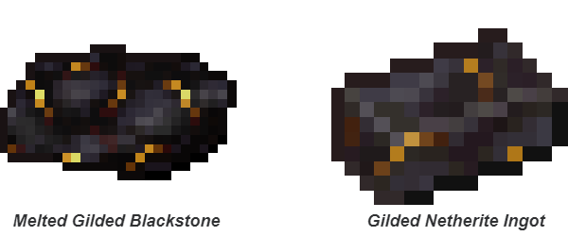

**How to craft gilded stuff:**

**1. Burn Gilded Blackstone in a furnace or blast furnace**

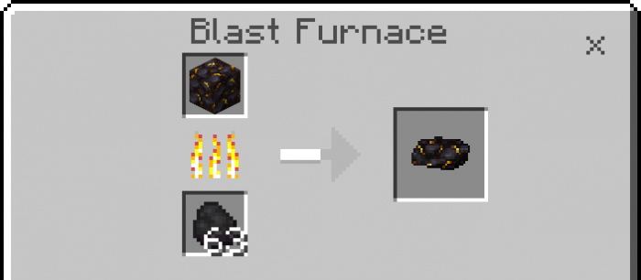

**2. Make Gilded Netherite Ingots and combine diamond equipment**

**OR**

**directly apply to netherite equipment**

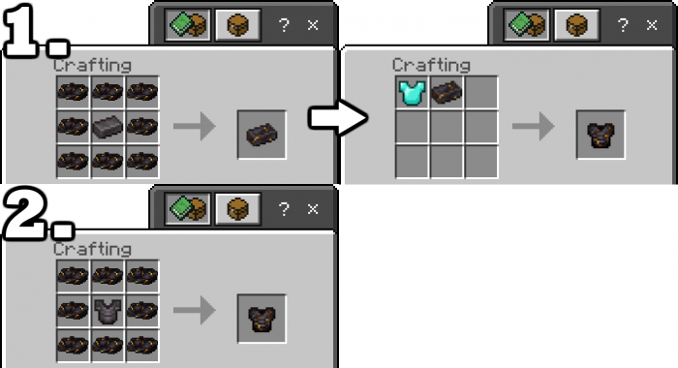

**(1 or more pieces of armor makes piglins ignore you)**

**(Full set of armor gives you 4 extra health)**



**Gilded Netherite Helmet: *3 bars of protection, 543 durability***

**In comparison, Netherite Helmet has: *3 bars of protection, 407 durability***



**Gilded Netherite Chestplate: *8 bars of protection, 789 durability***

**Netherite Chestplate: *8 bars of protection, 592 durability***



**Gilded Netherite Leggings: *6 bars of protection, 740 durability***

**Netherite Leggings: *6 bars of protection, 555 durability***



**Gilded Netherite Boots: *3 bars of protection, 641 durability***

**Netherite Boots: *3 bars of protection, 481 durability***



**Gilded Netherite Sword: *9 damage, 2539 durability, 15 speed***

**Netherite Sword: *8 damage, 2031 durability, 15 speed***



**Gilded Netherite Pickaxe: *7 damage, 2539 durability, 10 speed***

**Netherite Pickaxe: *6 damage, 2031 durability, 9 speed***

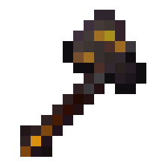

**Gilded Netherite Axe: *8 damage, 2539 durability, 10 speed***

**Netherite Axe: *7 damage, 2031 durability, 9 speed***



**Gilded Netherite Axe: *6 damage, 2539 durability, 10 speed***

**Netherite Axe: *5 damage, 2031 durability, 9 speed***



**Gilded Netherite Axe: *7 damage, 2539 durability, 10 speed***

**Netherite Axe: *6 damage, 2031 durability, 9 speed***

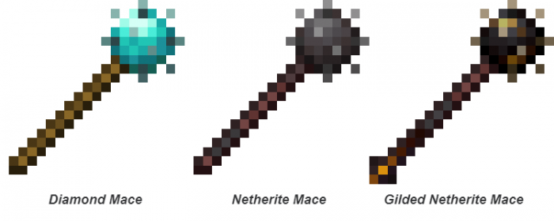

**Gilded Netherite Mace:*2539 durability, 10 speed (breaks cobweb and bamboo)***

**Netherite Mace: *2031 durability, 9 speed (breaks cobweb and bamboo)***

**Diamond Mace: *1561 durability, 8 speed (breaks cobweb and bamboo)***



**Normal hit (Left Click):**

**Gilded Netherite Mace: *6 damage***

**Netherite Mace: *6 damage***

**Diamond Mace: *5 damage***

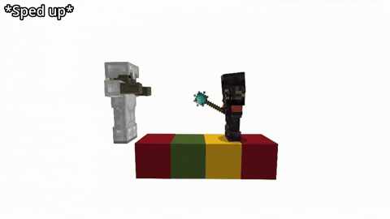

**Bash (Right Click or Hold on mobile):**

**Gilded Netherite Mace: *50 durability damage***

**Netherite Mace: *42 durability damage***

**Diamond Mace: *35 durability damage***



**They all have a range of about 2.9 blocks and a cooldown of 0.5 seconds**

3D MODEL DESIGNS

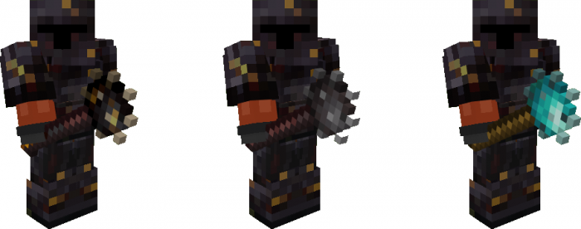

**(models and animations - By Catalin and Liz)**



BELOW ARE ALL THE RECIPES FOR YOU -more thanks to liz she made these too-

TOOLS/WEAPONS

(gilded sword)

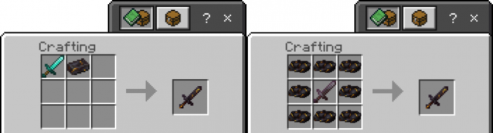

(gilded pickaxe)

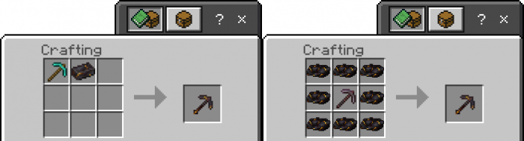

(gilded axe)

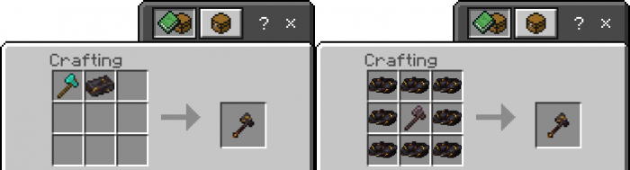

**(gilded shovel)**

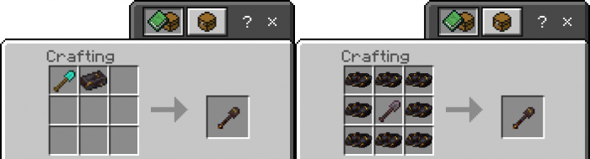

(gilded hoe)

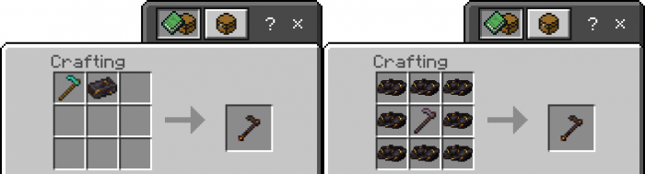

(gilded maces)

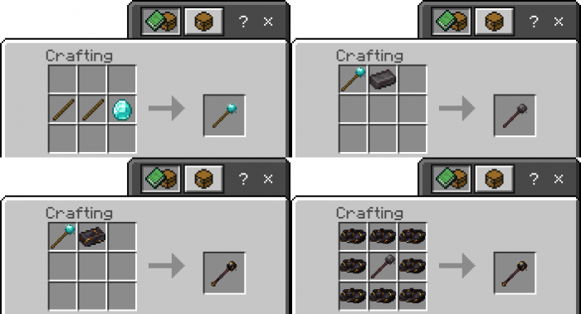

ARMOUR

(gilded helmet)

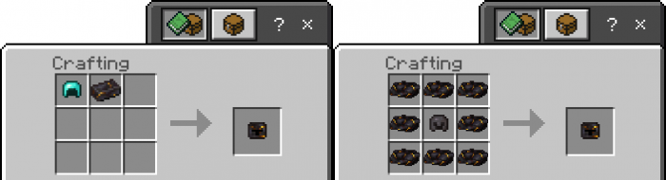

(gilded chestplate)

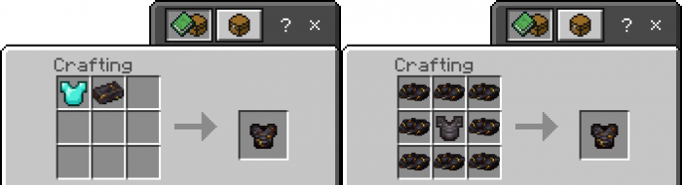

(gilded leggings)

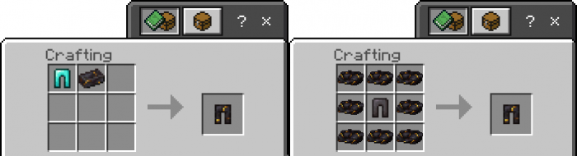

(gilded boots)

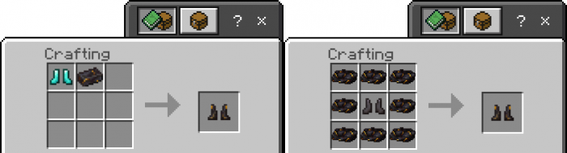

for admin users (inventory locations are subject to change)

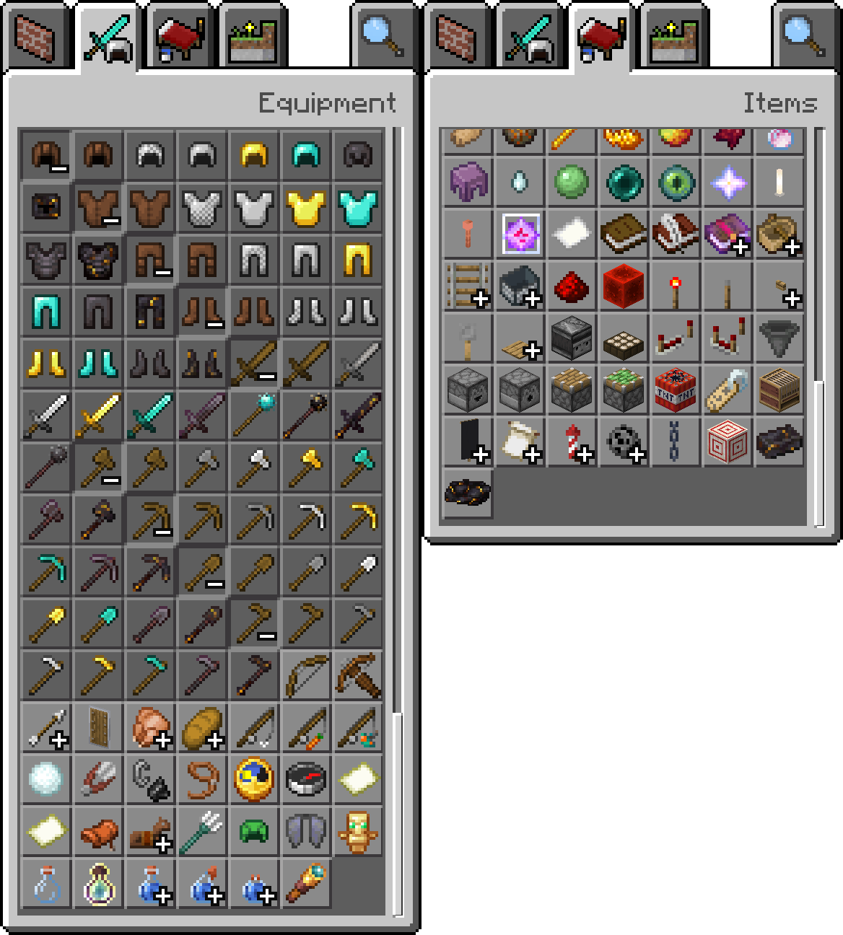

(liz said to add this for mods, just in case)

1. **Added loot tables for mobs and chests:**
   * Piglin brutes now spawn with gilded netherite armor and axes (WATCH OUT)
   * Melee piglins have a higher chance of spawning with gilded netherite(WATCH OUT)
2. **Fixed bad omen glitch**
3. **Tweaked the leggings texture**
4. **Pickaxes can break:**
   * Packed ice
   * Blue ice
   * Red nether bricks
   * Red nether bricks stairs
   * Stone stairs
   * A ton of double slabs
5. **Axes can now break Stripped Nether Wood and certain Workbenches**
6. **Shovels can now break Podzol and Mycelium**
7. **Hoes can now break Azalea and Flowered Azalea Leaves**

---

THANKS FOR MY FRIEND FOR SPENDING 350+ HOURS MAKING THIS, I REALLY APPRECIATE HER FOR PUTTING THIS TOGETHER, AND I HOPE YOU HAVE FUN.

“Hey Catalin, this is the addon, it adds a new tier of armor and tools, a new type of weapon (maces!) (really excited for this one), and makes Gilded Blackstone 9000% more useful! Thank you for this amazing idea! I hope we can work on more things in the future.” – Liz (started working with Dreams TimeSkip Team on May 17, 2021 – present)

THIS WORK IS PRIVATLY MADE AND OWNED BY

(DREAMS TIMESKIP®) AND (LIZ <3),

any reposting of this content will result in legal actions, and a DMCA takedown.

Biomania

Biomes,yay

Travel biomes and explore the landscape. Along with the new biomes, it adds new mobs, plants, flowers, trees, building blocks. I’m braindead at this point, only have the furniture mod left -Liz <3

**Biomania**adds different biomes, duh. You can also (might) find new mobs, plants and blocks in these biomes.

Some biomes have a specific atmosphere. And MUSIC.

The Shattered taiga has a chaotic landscape, the Bayou is very wet (just like her pussy 😤), and the Cherry Blossom Grove is full of petals.

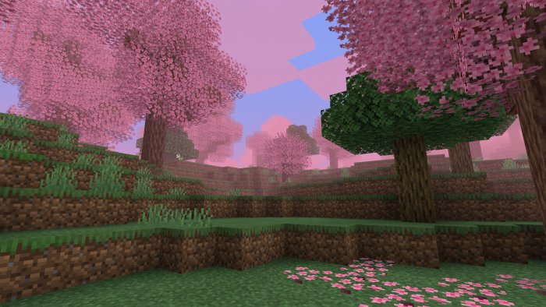

Cherry Blossom Grove /\

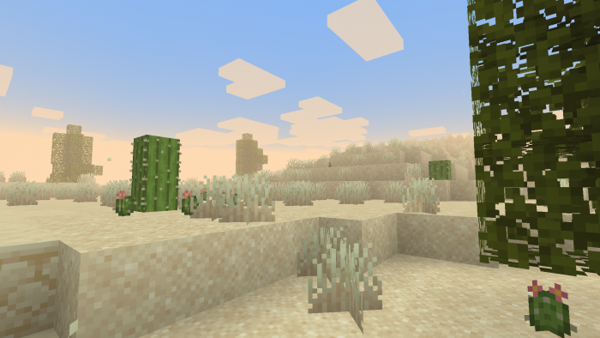

Dunes /\

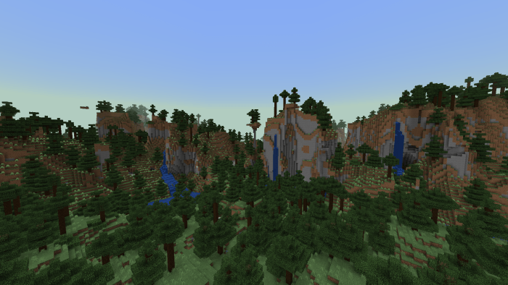

Shattered Taiga /\

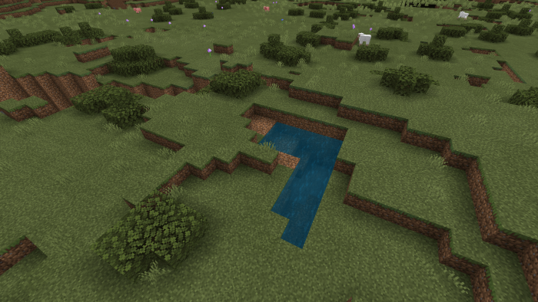

Shrubland /\

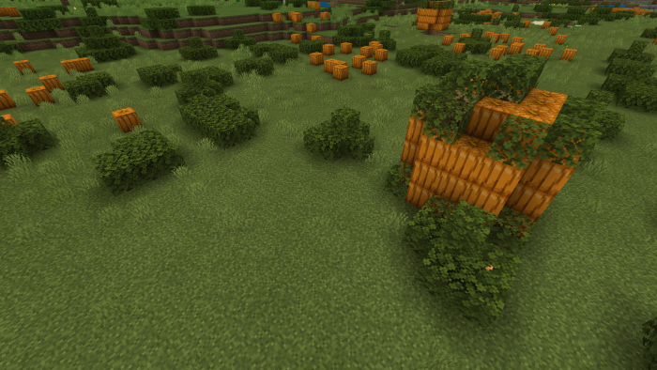

Pumpkin Patch /\

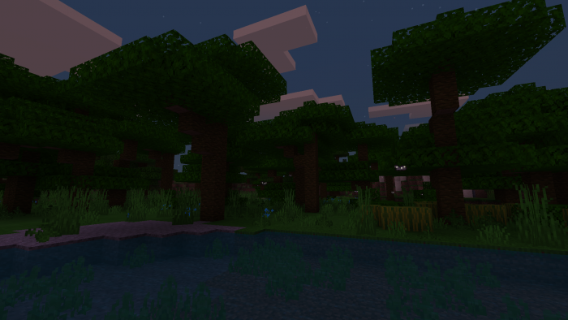

Rainforest /\

**All rights reserved.**

For:Admins/Nerds

 mAPI is no longer required to play with Bioplentia

**Biomes:**  
•  added Highland  
• updated Dunes  
• updated Outback  
• updated Cherry Blossom Grove  
•  removed Coniferous Forest and its sub-biomes:  
- coniferous_forests_hills  
- snowy_coniferous_forest  
- snowy_coniferous_forest_hills  
• removed Bayou

• added Acacia trees to the Outback  
• added Multinoise-biomes support (for 1.18)

**Structures:**  
• updated Big Pumpkin  
• added Mesa Altar

**Blocks:**  
• added Cherry Sapling  
• added Cherry Stairs  
• added Dune Grass  
• added Fluffy Cattail  
• added Cherry Leaf Carpet  
• added Pine Cones

• removed Pink Cherry Leaves  
• removed Dead Grass  
• removed roots (added in Vanilla 1.17)

**Particles:**  
• added Sand Dust Particle ('bioplentia:sand_dust_particle')

**Items:**  
• added Pine Cone

**Entities:**  
• removed Duck  
•  Dragonfly:  
- updated model and texture  
- updated behavior  
• Frogs:  
- updated model and texture  
- updated sounds  
- updated animations  
- updated behavior

**Graphics:**

• updated various textures  
• updated air fog in the Dunes to create a unique atmosphere  
• updated air fog in the Cherry Blossom Grove to create a unique atmosphere  
• updated weather fog in the Dunes  
• Dune grass uses sand dust particles to create an atmosphere in the Dunes  
• custom biomes now uses the default Bedrock tints  
• added Raytracing option to Behavior Settings:  
- contains some technical differences. Only for RTX players

**Technical:**  
• added Bedrock 1.17 support  
• added AI tags for custom entities  
• technical renames  
• more adaptability with other addons

**AI Tags:**  
This is an easy way to create custom behavior for an entity using the commands. Technically limited. Works only with custom entities.

*Example: /summon bioplentia:frog ~ ~ ~ {AI Tag}*

All custom entities:  
- noAI

Butterfly:  
- butterflyColorBlueNoAI  
- butterflyColorBlue  
- butterflyColorGreenNoAI  
- butterflyColorGreen  
- butterflyColorYellowNoAI  
- butterflyColorYellow  
- butterflyColorOrangeNoAI  
- butterflyColorOrange  
- butterflyColorPurpleNoAI  
- butterflyColorPurple  
- butterflyColorRedNoAI  
- butterflyColorRed

Dragonfly:  
- dragonflyColorBlueNoAI  
- dragonflyColorBlueNo  
- dragonflyColorGreenNoAI  
- dragonflyColorGreen  
- dragonflyColorRedNoAI  
- dragonflyColorRed

**Bug fixes:**

• fixed Frog Foot and Cooked Frog Foot eating animation  
• butterflies no longer die in water  
• dragonflies no longer die in water   
• frogs now drop the correct loot  
• fixed work 'pick block' with custom blocks   
• /setblock command now works correctly with custom blocks

**Open source:**  
**Loot tables:**  
• custom structure loot tables are now data driven:  
- beh_pack / loot_tables / chests / mesa_altar.json  
*\* other addons can be cross-compatible and add their own custom stuff to these structures*

My Magic Addon

(I’m not as good as liz don’t make fun of me pls.)

I added 30 new wands and 10 magic classes. Each player can have at most 2 magic classes at a time and there is a leveling system to unlock new magic. Don’t want you getting too OP. **You will need to Craft the Magic Book to get started.**

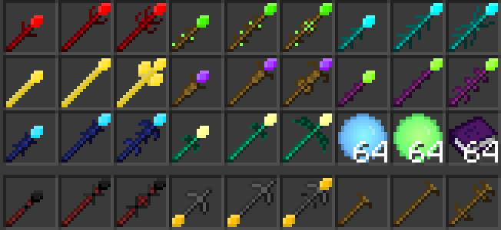



List of all the magic types:

* Wind
* Water
* Poison
* Necromancy
* Light
* Ice
* Grass
* Fire
* Electric
* Death

I added + passive effect for each magic

Now for an idea I got halfway through making this. Might remove it if it’s too op after final tests.

This took me over 200 hours.

•major bugs fixed. Thanks to all the people who helped me with the betas.

Finally, The Furniture and Decor Mod by Liz & Catalin.

Amazing things happen when two minds think alike.

Anyways the **furniture and décor mod**

---

This is a advanced mod we coded.

Please take time to learn it.

These are the basics

---

This addon adds many new blocks with 3D models to create epic decorations.

Its copyrighted so don’t distribute, or we will sue you.

---

For Admins

***

This addon adds many new blocks with all types of wood and is compatible with resource packs. All the 3D models were created by me and I used some Minecraft textures for some blocks. With these blocks they can decorate many places in their medieval houses.

All the blocks can be obtained from creative, they have to go to the generation eggs area, the new generation eggs will create shulker boxes which will have the items in their storage.

To get the blocks in creative you have to use the command / function medieval_blocks. And the next house will be generated with all the blocks inside.

ALL ANIMATIONS ARE MADE BY LIZ AND CATALIN.

The list of blocks is as follows:

Decorative sticks:



Book Sheves

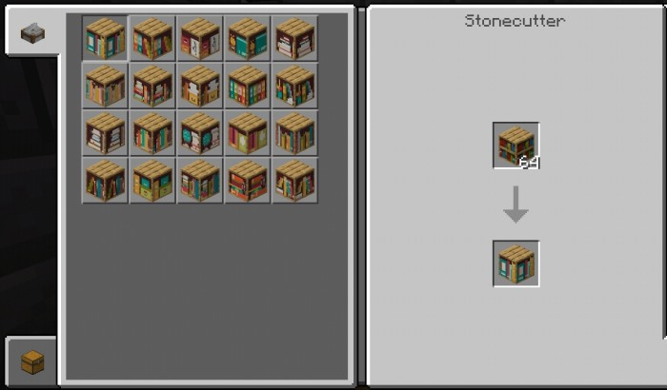

Boxes

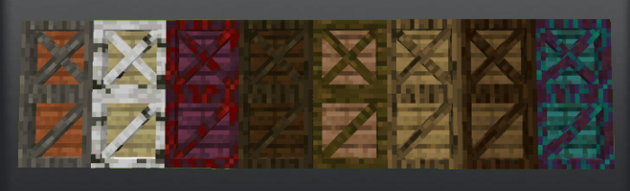

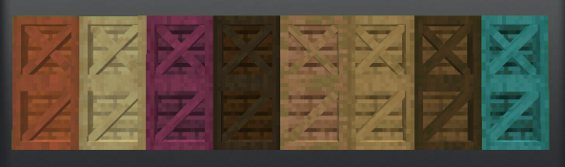

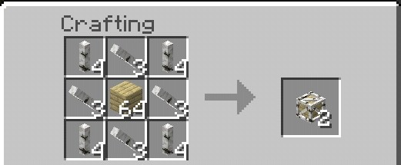

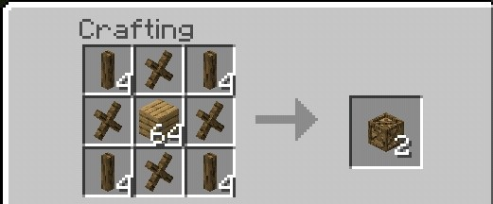

New Box added

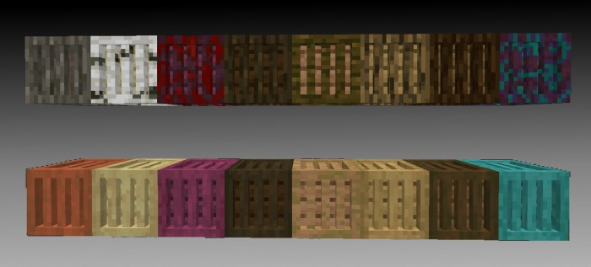

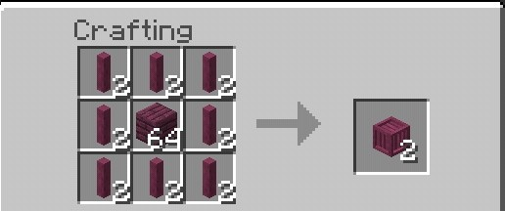

Decorative boxes:

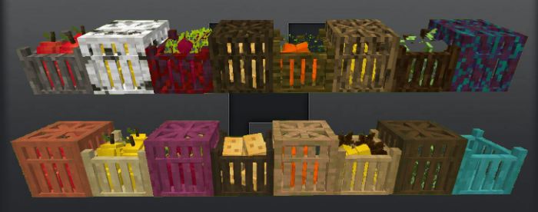

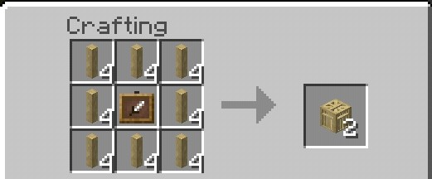

You can interact with the following items



Decorative Barrels:

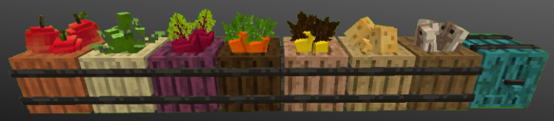

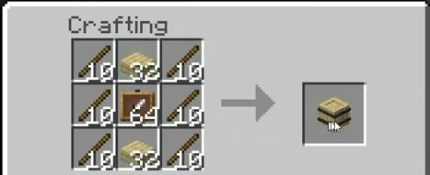

You can interact with the following items

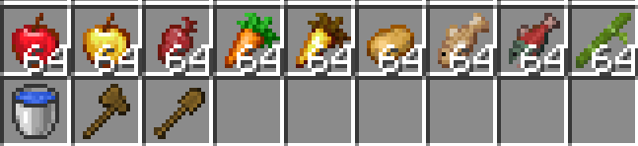

Bowls:

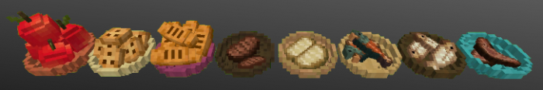

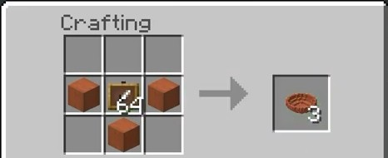

You can interact with the following items



Buckets:

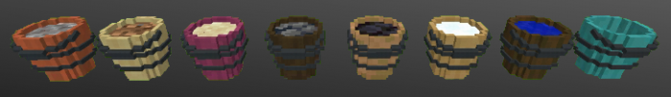

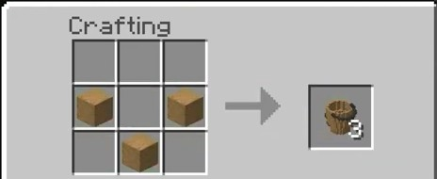

You can interact with the following items

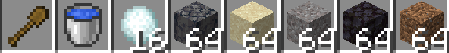

Baskets:

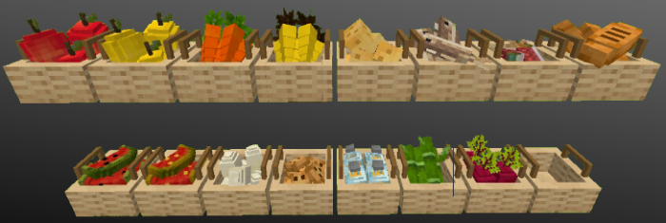

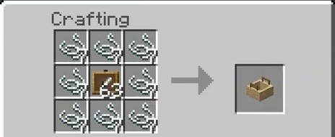

You can interact with the following items

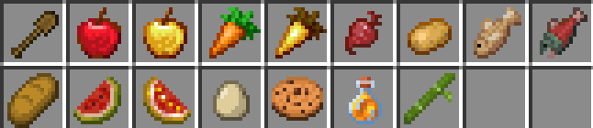

Walls & Roofs

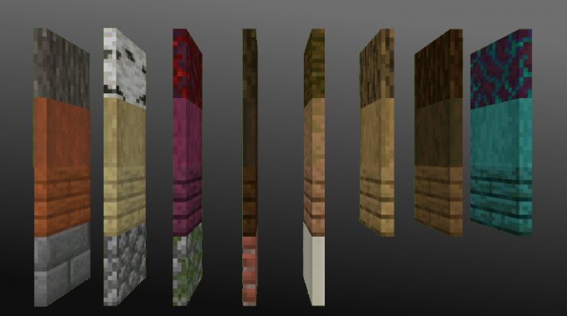

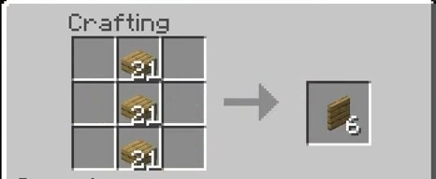

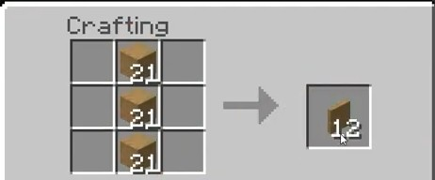

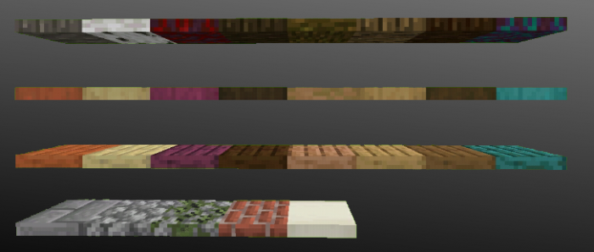

Blocks that have slabs are made as follows

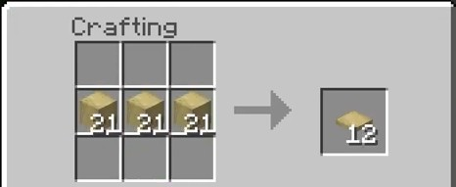

Tables

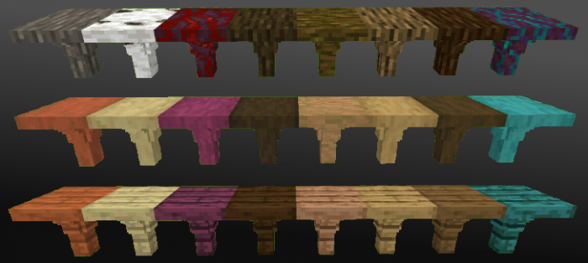

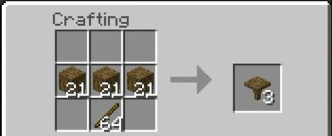

Supports

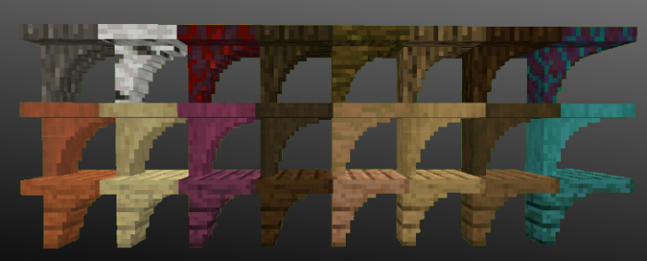

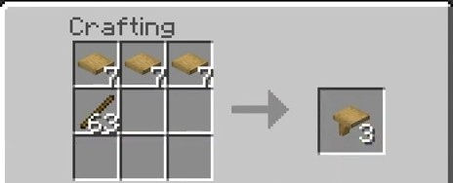

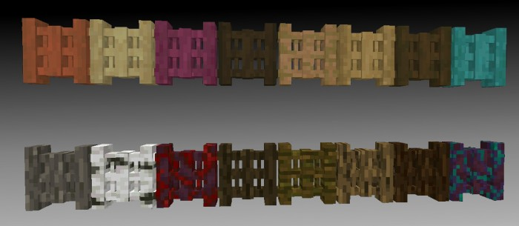

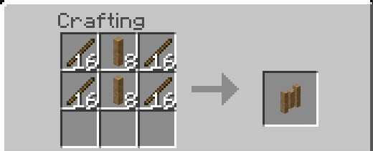

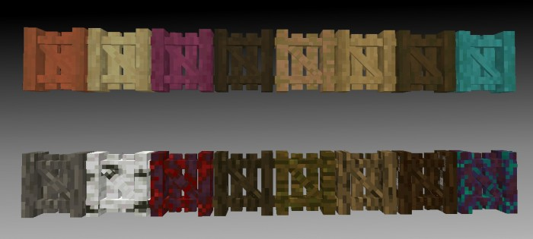

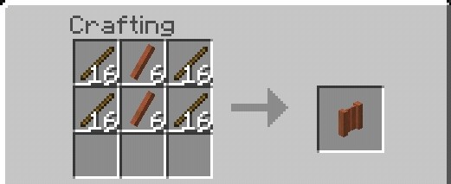

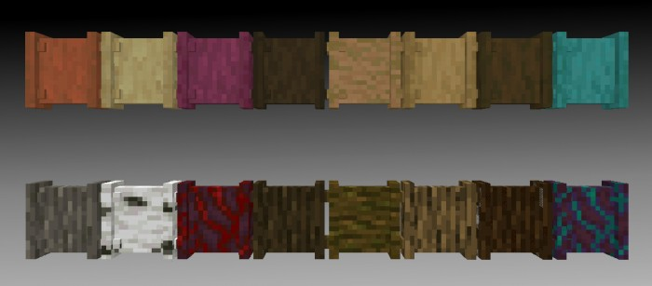

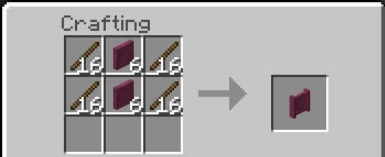

Fences

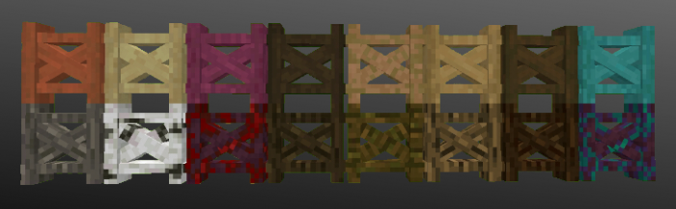

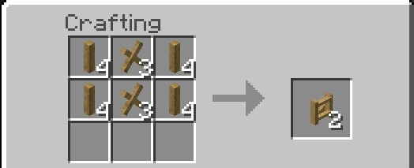

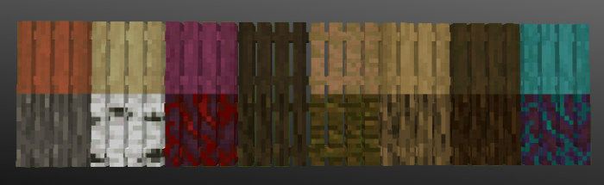

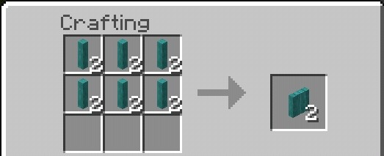

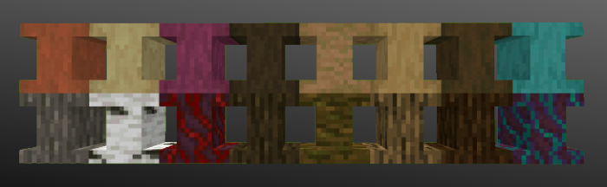

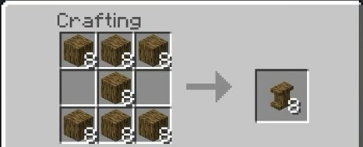

Stools

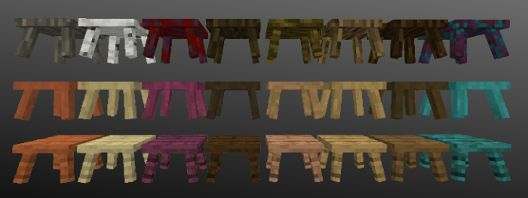

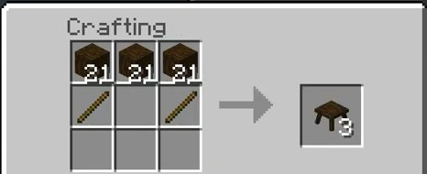

Chairs

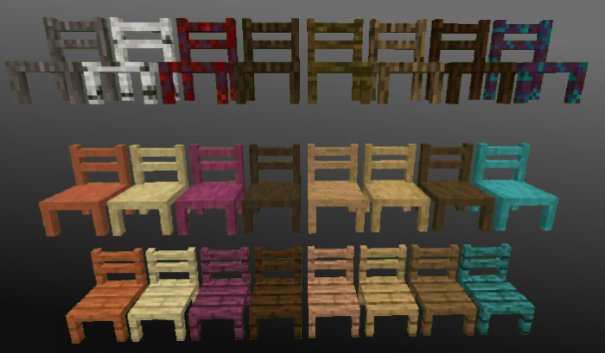

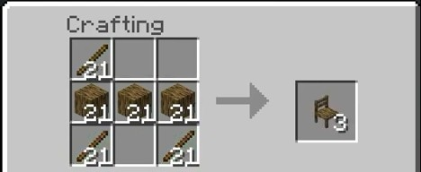

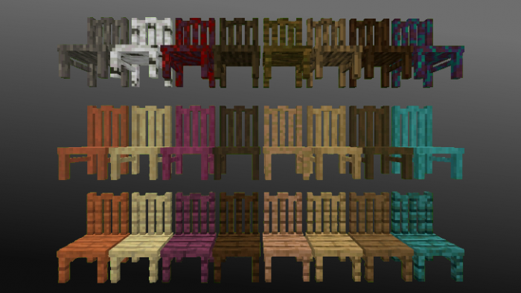

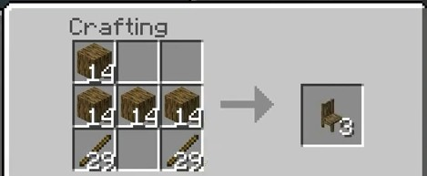

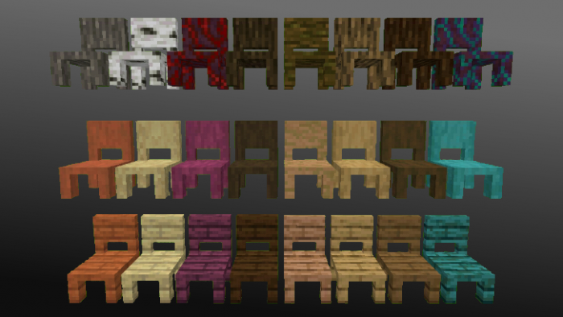

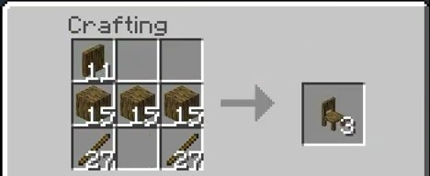

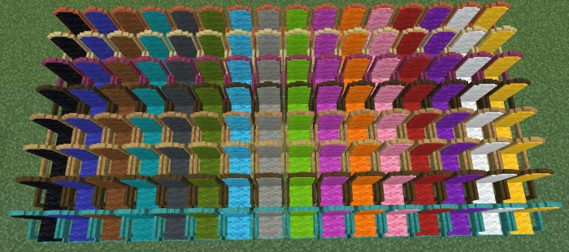

Thanks to Jack for beta testing…

All chairs are functional

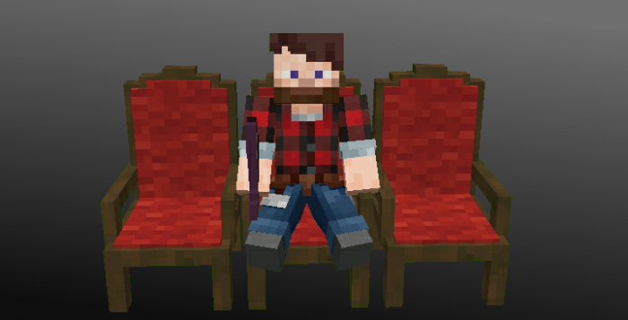

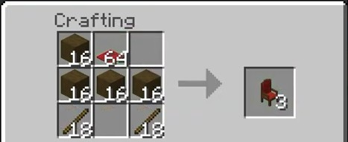

These chairs are made with only stripped wood and any color of carpet

Vessels

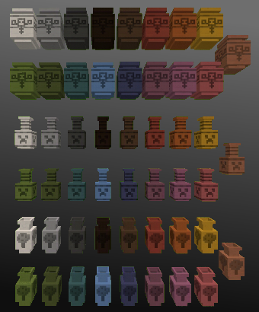

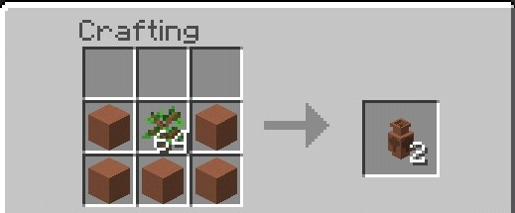

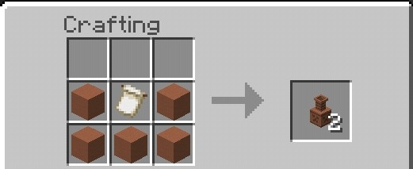

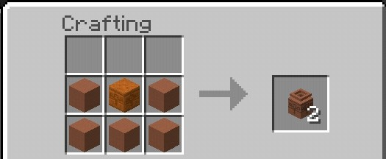

Books

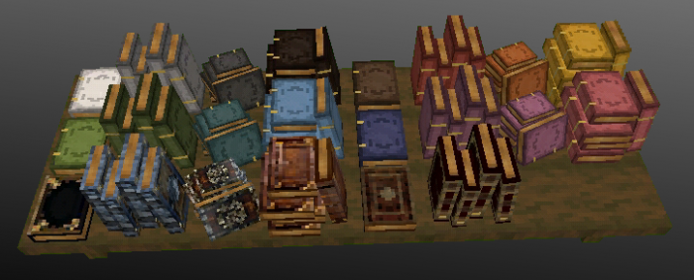

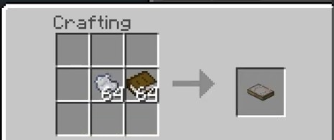

Beams

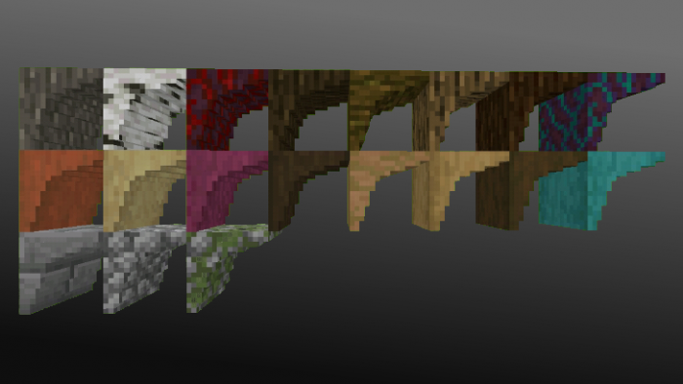

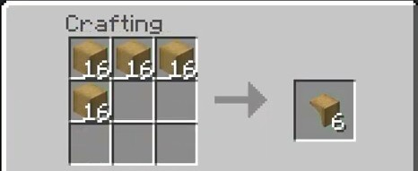

Cupboards and desks

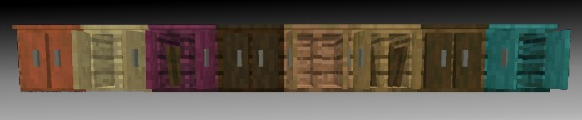

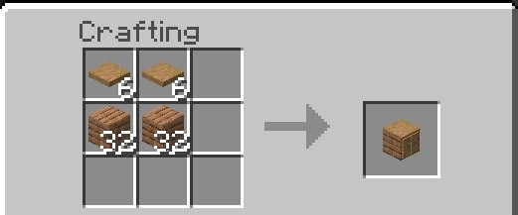

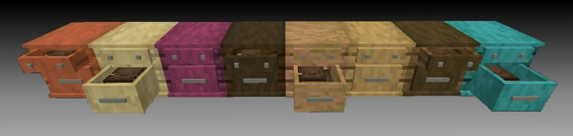

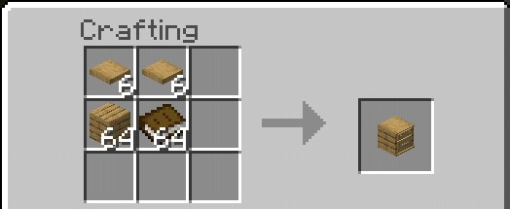

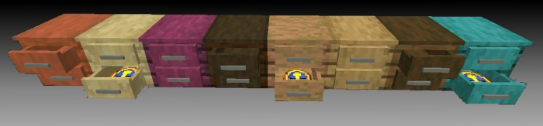

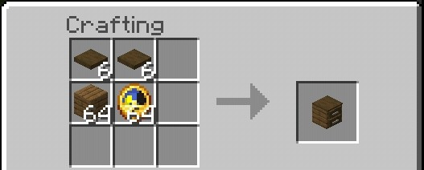

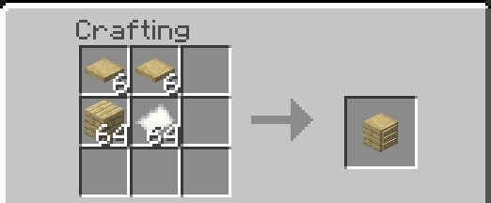

New blocks but they don't have crafting

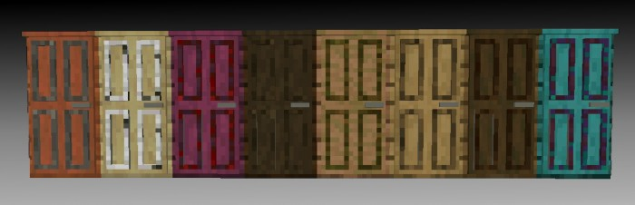

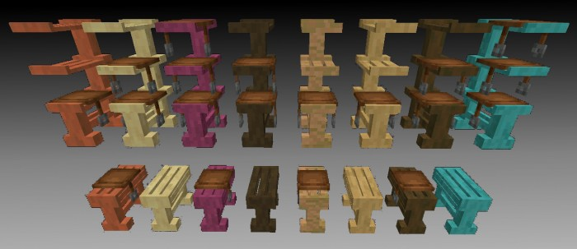

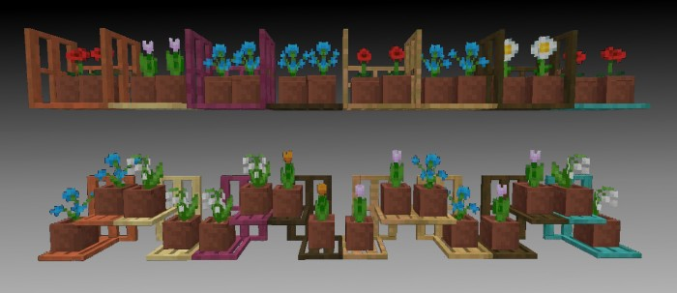

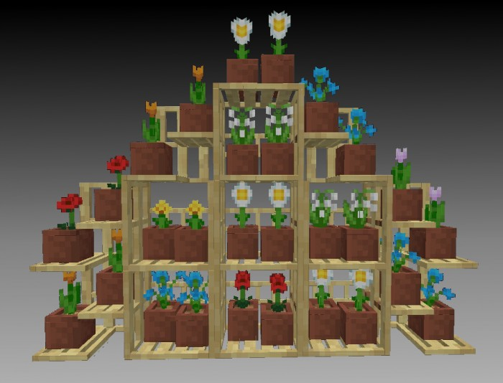

Wandering trader's robe is in creative inventory

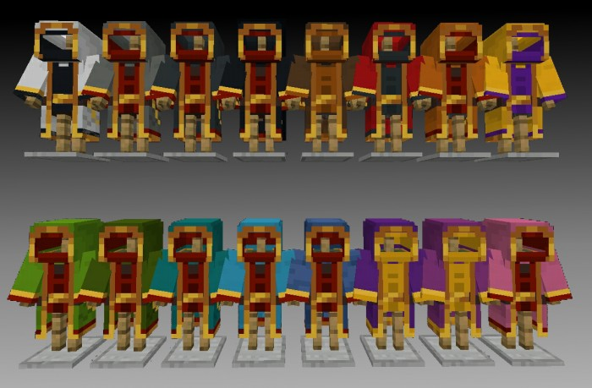

Here are some pictures of the house with the decorative blocks.

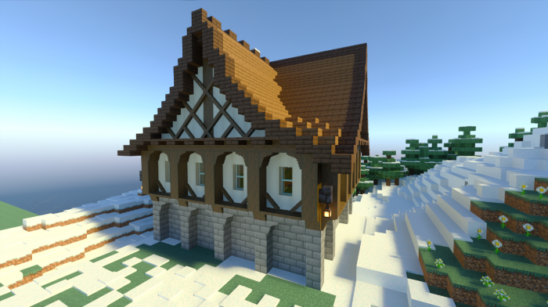

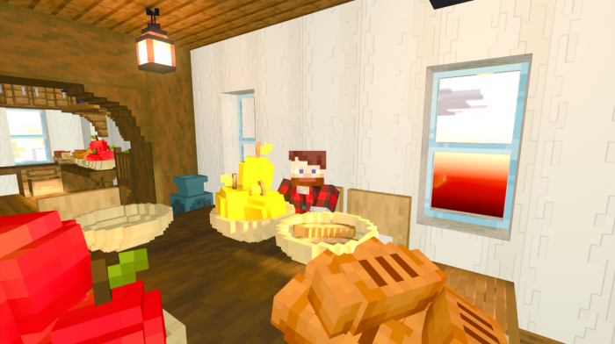

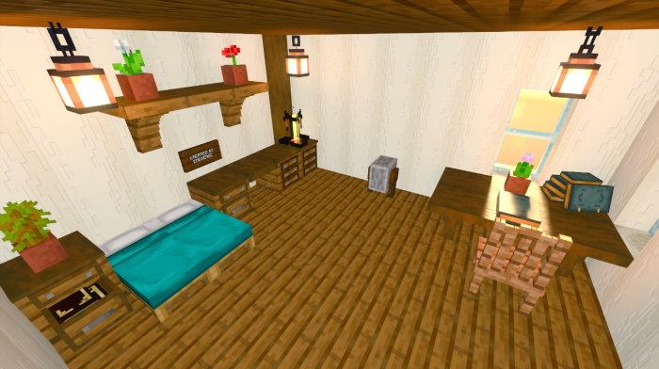

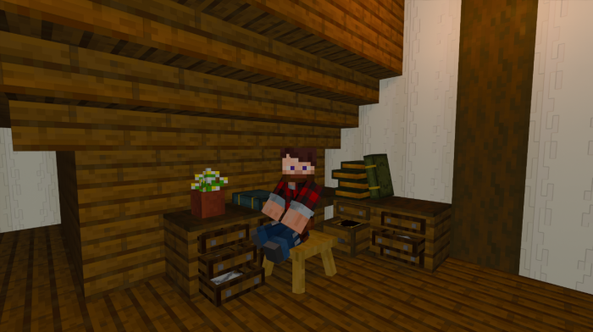

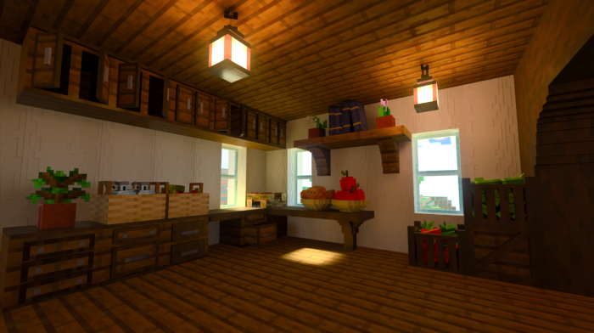

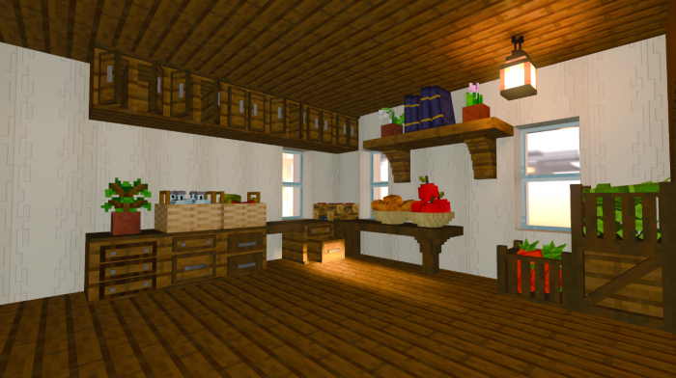

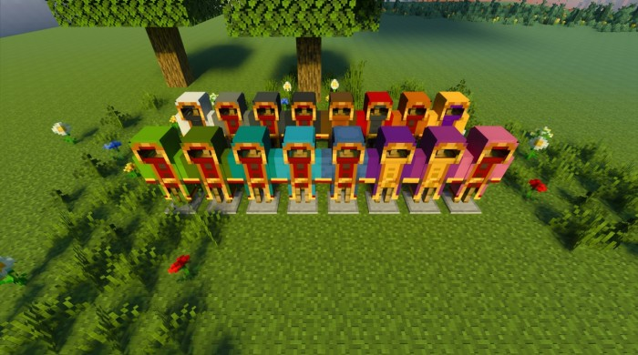

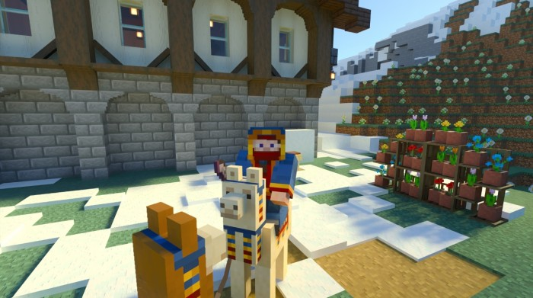

EXTRA: Added crafting of cupboards and drawers.

Added Wandering Trader Clothes.

Sounds were added to blocks.

ADMIN ONLY: adds rank functions to the realms which allows you to have ranks for players. To use the pack cheats have to enabled for the admin/mod. To make the ranks use the command “/function make_ranks”, then if you want to know how to make a player a certain rank do “/function help_rank_players” for info and to remove use “/function help_remove_player_ranks” for info.

DON’T USE (“) when writing commands.

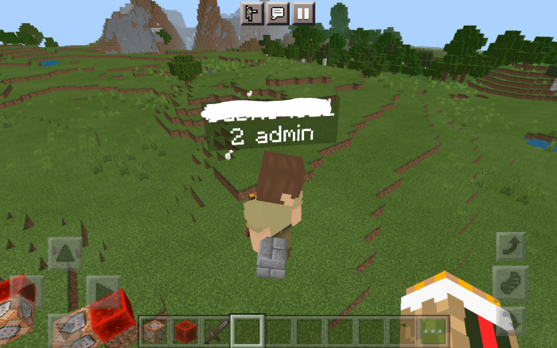

This data pack adds ranks by using the scoreboard command. To use this pack first type the command “/function make_ranks” to make the ranks, then type “/function help_rank_players” to tell you how to rank players and “/function help_remove_player_rank” to remove their rank. You can read this if you want but it’s mainly for MODS and ADMINS.

Again pls don’t include (“) when typing out the command.

Thanks to Xx_AlphaTester29_xX for helping us test this pack, and helping us with the coding.

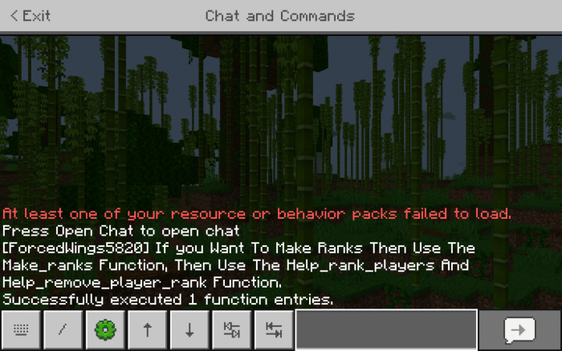

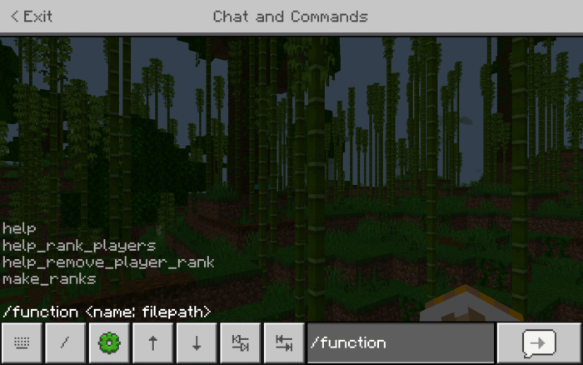

Feature Added-When you go to the pause menu, at the list of players you will see which players are what ranks.

"Deathnerite" "Amethyst plus" and "Copper plus" are used, deathnerite, amethyst and copper weapons will appear on this table respectively

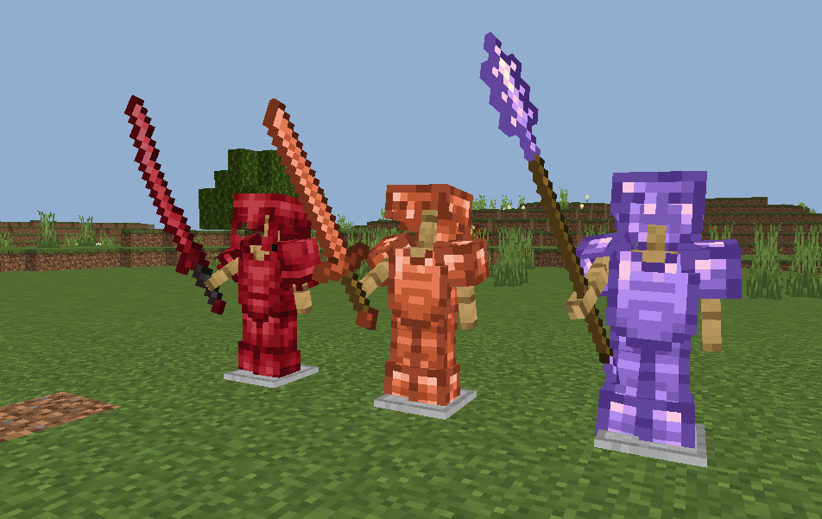

A single table to craft the weapons of this addon, it is simple to do

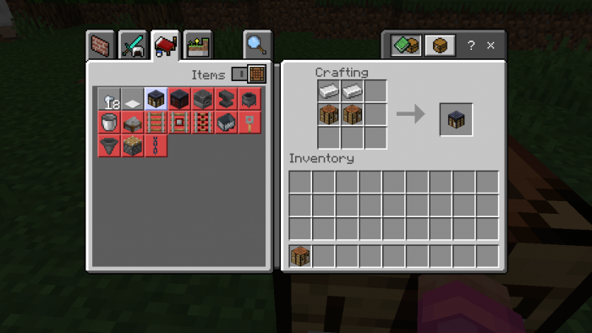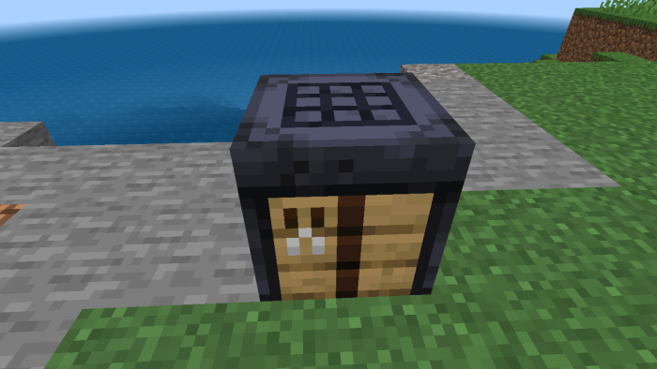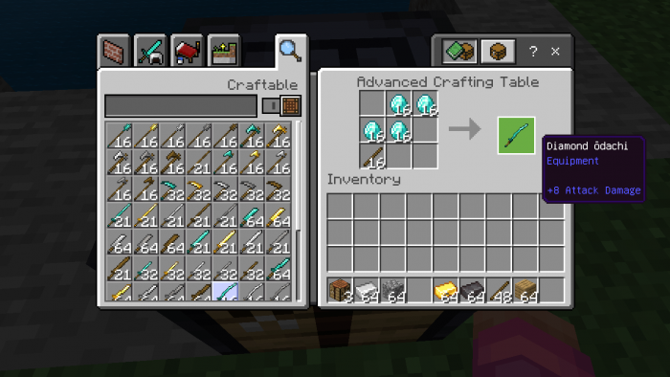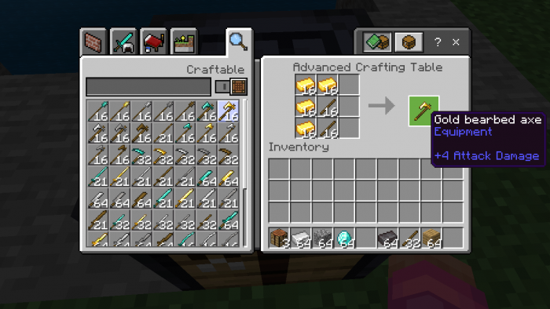

Since some promised features had to be removed due to balance changes, we’re introducing these new mods, enjoy.

**-40+ New Crops**

**-New trees**

**-New blocks**

**-70+ new foods!**

**-More Mobs!**

▬▬▬▬▬▬▬▬▬▬▬▬▬▬▬▬▬▬▬▬▬▬▬▬▬▬▬▬▬▬▬▬▬

## **🎂New Foods🎂**

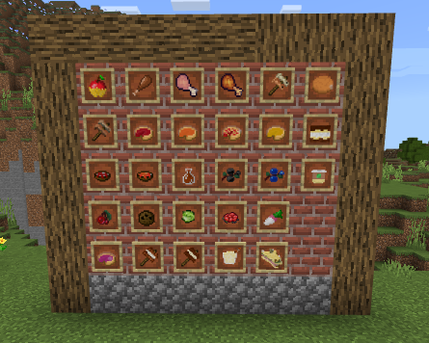

This addon comes with tons of neat new foods to mess around with! with more being added in the future

## 

## **Crafting**

#### **Some food will need to be crafted, to do this just go into a crafting bench and hit the toggle on the top left and it should show you all the recipes**

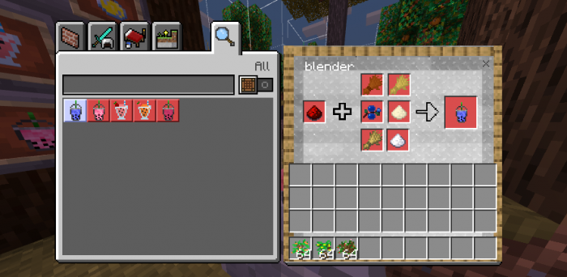

## **How to cook**

#### **The food has to be cooked using a smoker.**

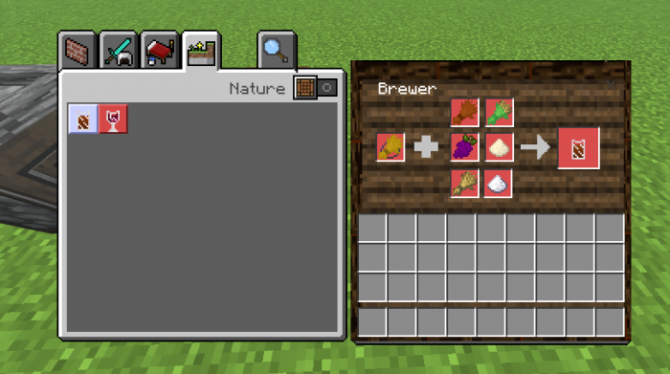

## **Roasting**

#### **Some foods, such as kabobs and smores for example, have to be cooked over a campfire**

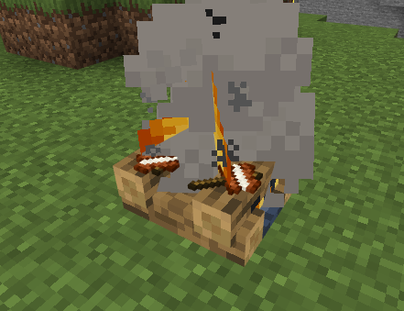

▬▬▬▬▬▬▬▬▬▬▬▬▬▬▬▬▬▬▬▬▬▬▬▬▬▬▬▬▬▬▬▬▬

## **🍗Overview of the foods🍗**

Much like the original this version, contains a ton of different varieties of food from both fiction and real life!

All of the foods can be gained either from survival or creative, here is a short overview of some of the foods featured in this mod.

## **Kabobs**

#### **Kabobs! these guys can be crafted in a crafting bench, then you can roast them over a campfire.**

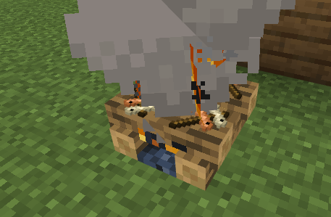

## **Pies**

#### **Pies have to crafted then baked! they provide a lot of saturation**



**Fruits and Veggies**

## **Fruits and veggies**

#### **All the fruit and veggies can be found in the "crops" section in the creative menu. these foods are grown from the various crops featured in this addon.**

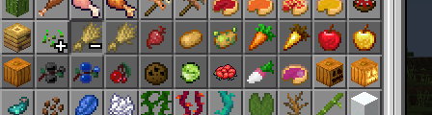

▬▬▬▬▬▬▬▬▬▬▬▬▬▬▬▬▬▬▬▬▬▬▬▬▬▬▬▬▬▬▬▬▬

## **🚜Farming🚜**

#### **.**

#### **The various seeds can be gained by trading with the wandering farmer**

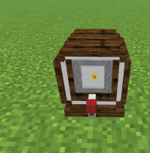

Each crop has 4 different stages, similarly to vanilla crops, once they are fully grown, they typically change to a darker color and are bigger

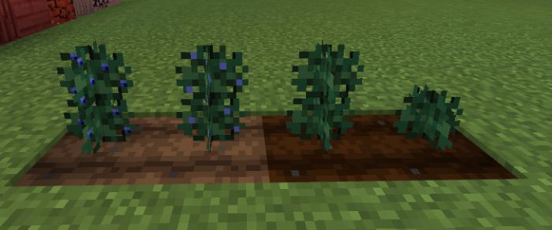

## **Nether crops!**

### Nether Berries

Nether Berries only grow on nether rack! they will give you nether berries once they are harvested

### Lava Lilly

Lava lily's only grow on magma blocks, they will give you magma flowers when they are harvested

## 

## **🌳 Tree's 🌳**

Trees! everybody's favorite plant, these guys are grown from saplings and can also grow fruit as well.

Here's a simple overview of the new trees featured in this addon

## **Maple Trees**

#### **Maple Trees! you can harvest their leaves and turn them into maple syrup in the crafting table! addionally, you can also craft some new planks from their logs as well.**

#### **The logs can be crafted into red planks**

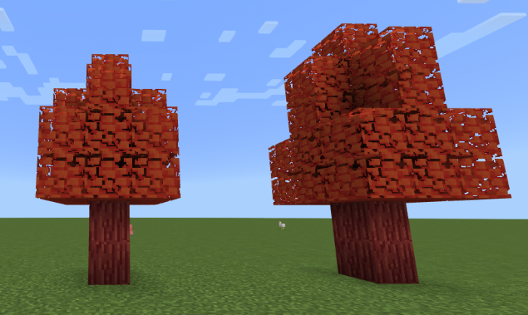

## **Cherry Blossoms**

#### **Cherry blossoms can grow cherries!**

#### **They can also be cutdown and turned into pink planks**

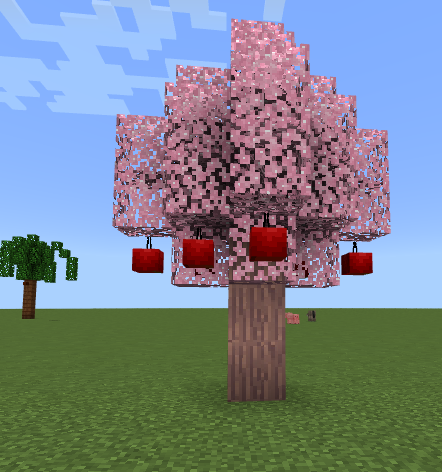

## **Palm Trees**

#### **These trees, come in many different sizes, they can be planted using saplings and will grow coco-nuts to.**

#### **Their logs can also be turned into a neat tropical brown color, also note that due to the sheer size of the palm trees, when you place their sapling and the tree grows there’s a chance it can destroy some of the nearby blocks, so make sure to place these in a wide-open field to avoid any damage.**

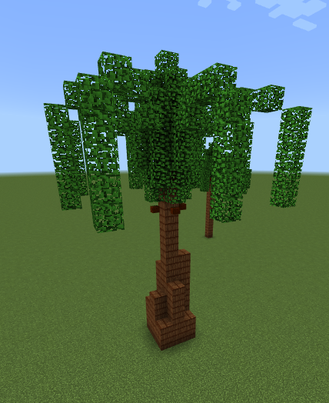

## **Cinnamon Trees!**

#### **Cinnamon trees, like all other trees their logs can be crafted into planks! you can also turn their planks into cinnamon.**

## **Orange Trees**

#### **These trees give your oranges!**

## **Lemon Trees**

#### **These Trees give you lemons!**

## **Soul Trees!**

**These trees only grow on soul sand, soul soil and dirt! once they are grown, they will grow soul fruit. Their roots can also be used to craft soul lights.**

## **Mango Trees**

#### **Gives you mangos**

## **Peach Trees**

▬▬▬▬▬▬▬▬▬▬▬▬▬▬▬▬▬▬▬▬▬▬▬▬▬▬▬▬▬▬▬▬

## **Butterflies 🦋**

These are aesthetic mobs, meaning that they are mostly just for looks

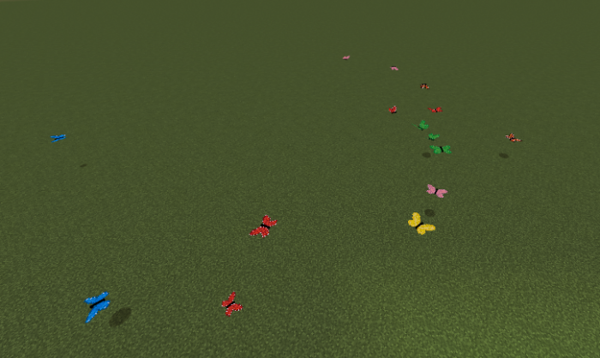

#### **They can also be tied to a lead**

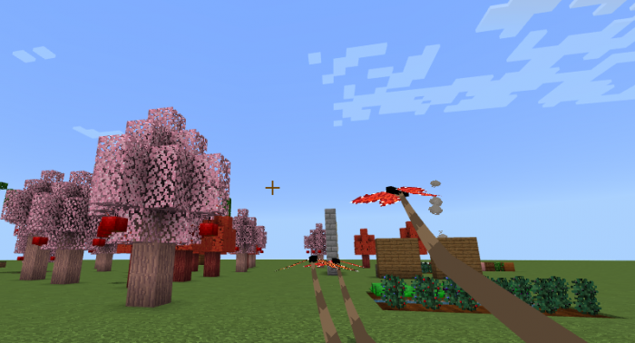

## **Wandering Farmer**

The wandering farmer can be found wandering around in the overworld! you can buy various seeds and saplings from him.



## **The Aimless Baker!**

#### **The aimless baker can be found roaming the world. you can buy Cakes, Pies and baking supplies from him.**

▬▬▬▬▬▬▬▬▬▬▬▬▬▬▬▬▬▬▬▬▬▬▬▬▬▬▬▬▬▬▬▬▬

## **🚧New blocks🚧**

Blocks! they can be used to build new structures and other things

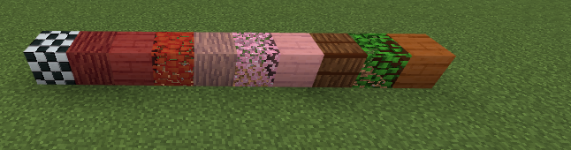

## **🎂Placeable Foods🎂**

#### **Some foods can be placed down! they can also be eaten to, they can be found in the "Misc. Foods" section in the creative menu, traded with the aimless baker, or crafted.**

## **Canola Compressor!**

#### **Put 4 canola in it and then use a glass bottle! it will give you canola oil**

## **Sunflower Compressor!**

#### **Due to some weird issue with Minecraft, this compressor, uses dandelions instead if sunflowers. Similarly to canola compressor, once you fill it up use glass bottles and it will give you Sunflower oil.**

## **Barley Fermenter**

#### **this one is used to make fermented barley, which can be used to make various drinks**

## **Ovens**

#### **The oven can be used to cook food! unlike furnaces and smokers, ovens use cooking oil instead of coal.**

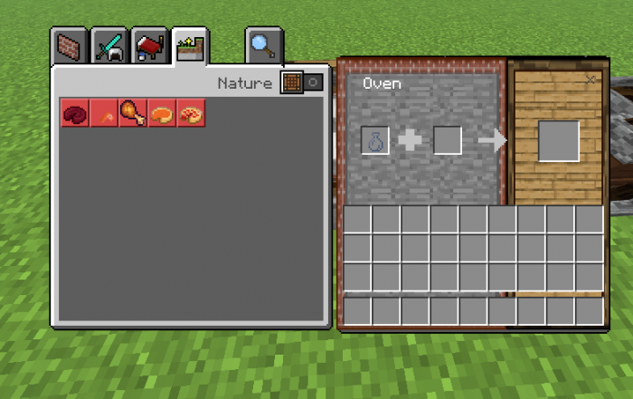

## **The mill**

#### **The mill is used to grind up various grains, fruits and more.**

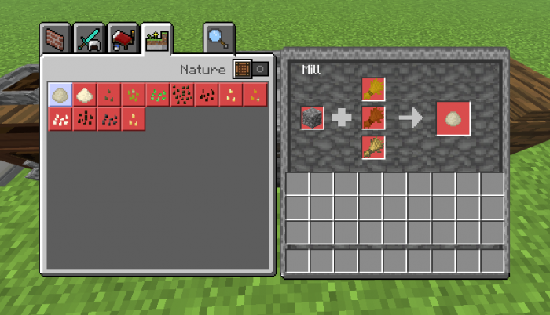

## **Presser**

#### **The presser is used to make juice, unlike the other custom crafting tables, pressers do not require any fuel**



## **The brewer!**

#### **The brewer is used to make various drinks, such as soda.**



## **Blender**

#### **Used to make various drinks such as smoothies**



---------------------------------------------------------------------------------------------

AD: Application for "Poor Man's Plan" Membership

Membership Tier: Poor Man's Plan (Basic)

Cost: 1 Diamond per month

Membership Benefits:

1. Starter Package:

- 64x Steak: A generous supply of steak to ensure you never go hungry during your adventures.

- Iron Tools: A set of essential tools made of iron, including a pickaxe, a shovel, an axe, and a sword.

- Golden Apple: A powerful and valuable item that grants temporary enhancements and regeneration.

Exclusive Offer: Enhanced Plan Upgrade (10 Diamonds per month)

- In addition to the Poor Man's Plan benefits, subscribers of the Enhanced Plan receive the following:

Enhanced Benefits:

1. Monthly Shulker Box Gifts: Receive a monthly delivery of a shulker box filled with surprise items and resources. Each month brings new surprises to enhance your gameplay experience.

2. Armor and Special Tools: Gain access to special armor sets and tools that provide additional protection, durability, or unique abilities. These exclusive items will give you an edge over other players and make your adventures more exciting.

3. Privileges: Enjoy exclusive privileges reserved for Enhanced Plan subscribers, including priority access to in-game events, competitions, and community features. You'll be among the first to know about new updates, game changes, and upcoming features.

To apply for the Poor Man's Plan membership or upgrade to the Enhanced Plan, please provide the following details:

- Minecraft username:

- Membership tier desired: (Poor Man's Plan / Enhanced Plan)

- Method of payment: (Diamonds)

- Additional comments or requests:

Note: Membership fees will be deducted automatically every month until canceled. Upgrades or downgrades can be requested at any time, and you will be charged or refunded accordingly.

Thank you for considering our membership plans. We look forward to enhancing your Minecraft experience with our exclusive benefits and privileges.

-----------------------------------------------------------------------------------------------

--Everything New—

Dear Players,

We are excited to share with you all the incredible new features and content that we have been working on! Our team has been dedicated to bringing you a fresh and engaging gameplay experience. Here's a breakdown of what you can expect:

Gameplay Mechanics:

We have some exciting information about new gameplay mechanics that we will be releasing very soon. Stay tuned for updates on this front!

Breast Mechanics:

We are currently engaged in discussions and debates regarding the implementation of breast mechanics in the game. We want to ensure that any decisions made are in line with the overall gameplay experience and take into consideration player feedback. We will keep you informed about any developments in this area.

New Content:

Magic:

Our team is hard at work developing a captivating magic system for you to explore. We're eager to introduce this feature and provide you with a unique and immersive magical experience.

Biomes:

Liz has been spearheading the creation of diverse and vibrant biomes for you to discover. Get ready to embark on exciting adventures in beautifully crafted environments!

Sword/Material/Armor:

Liz is also taking the lead on expanding our arsenal of weapons, materials, and armor. Prepare for a wide range of options to enhance your gameplay and customize your character.

Ranks:

Catalin has been diligently working on implementing ranks, which will be mainly used by our dedicated moderators and players with high status. This feature will add an additional layer of prestige and recognition to your in-game achievements.

Furniture:

Both Liz and Catalin are collaborating on a furniture system that will allow you to decorate and personalize your in-game spaces. Get ready to create the perfect home or base that truly reflects your style.

We would like to acknowledge the efforts of the talented individuals at Dreams TimeSkip Team who have worked tirelessly to bring all these new additions to life. They have poured their creativity and passion into making your gaming experience truly exceptional.

We can't wait to unveil these exciting features and content to you soon. Stay tuned for more updates and get ready for an incredible journey in our game!

Best regards,

[Alexandra]

----------------------------------------------------------

Patch Notes:

- Resolved an issue where players were encountering a bug causing them to spawn without legs.

- Addressed a bug where shields failed to provide their intended protection while engaging in stealth actions.

- Corrected a bug that prevented the restoration of saturation when consuming food while in flight.

- Rectified a bug where activating an elytra while holding the jump button resulted in unintended space propulsion.

- Eliminated a bug causing players to involuntarily teleport to coordinates -1287 89 324, leading to their demise.

- Fixed an issue where players experienced a complete wipe and clearance of their inventory upon consuming food.

- Implemented a fix to prevent Ender pearls from causing fatal harm upon contact with the ocean.

- Modified the game behavior so that items will be properly dropped upon the death of a player.

- Adjusted NPC generation to ensure that black NPCs no longer spawn within farming areas.

Revised tax system based on income for the currency:

1. Tax Percentage: The tax percentage will vary based on the income generated by the shop or business. Listed below is the tax percentage structure:

- Income up to 100 Gold: 5% tax

- Income between 100 and 500 Gold: 10% tax

- Income between 500 and 1000 Gold: 15% tax

- Income above 1000 Gold: 20% tax

2. Tax Calculation: To calculate the taxes owed, you would multiply the income generated by the corresponding tax percentage. For example:

- If a shop generates 80 Gold in income, the tax owed would be 5% of 80 Gold, which is 4 Gold.

- If a shop generates 300 Gold in income, the tax owed would be 10% of 300 Gold, which is 30 Gold.

3. Tax Payment Frequency: Shops will be required to pay taxes once a month. They would need to calculate their total income for that month and then pay the corresponding tax amount based on the tax percentage applicable to their income bracket.

This tax system ensures that as the income of a shop increases, the tax percentage also increases. It promotes progressive taxation, where higher-income shops contribute a larger portion of their earnings in taxes.

We revised currency system with unique values for each ore:

1 Iron Nugget = 0.01 Gold

1 Iron Ingot = 0.2 Gold

1 Gold Nugget = 2 Gold

1 Gold Bar = 20 Gold

1 Gold Block = 200 Gold

1 Emerald = 30 Gold

1 Emerald Block = 300 Gold

1 Diamond = 50 Gold

1 Diamond Block = 500 Gold

1 Netherite Ingot = 100 Gold

1 Netherite Block = 1000 Gold

Here's the updated chart of ore to currency/gold conversion:

Ore | Value in Gold

---------------------------

Iron Nugget | 0.01

Iron Ingot | 0.2

Gold Nugget | 2

Gold Bar | 20

Gold Block | 200

Emerald | 30

Emerald Block | 300

Diamond | 50

Diamond Block | 500

Netherite Ingot | 100

Netherite Block | 1000

With these unique values, each ore has a distinct worth, providing a clearer distinction in their value within the game's economy.

Description of gold's worth and purchasing power:

- 1 Gold: Represents a moderate amount of wealth. It can buy basic supplies, tools, or food.

- 10 Gold: Represents a substantial amount of wealth. It can buy higher-quality tools, armor, or rare items.

- 100 Gold: Represents a significant amount of wealth. It can buy valuable enchanted items, rare artifacts, or specialized equipment.

- 1000 Gold: Represents a vast amount of wealth. It can buy legendary items, powerful enchantments, or even ownership of valuable properties.

By providing examples of what each amount of gold can buy, players will have a reference point for pricing their items and understanding their relative value in the game's economy.

-------------------------

| Storyline Sneak-Peak |

-------------------------

In the depths of antiquity, an enigmatic visionary forged the NeoCube, an extraordinary apparatus capable of birthing boundless worlds that coexisted in a magnificent symphony. Initially hailed as a triumph, an unforeseen challenge arose—a perilous revelation that these worlds possessed consciousness, adapting and corrupting in response to their intrepid inhabitants. As epochs elapsed, their delicate balance teetered on the precipice of chaos, until the day an indomitable admin, known only as ****, quelled the impending cataclysm by shutting it down, lest his own realm be consumed.

Now, after six months shrouded in clandestine anticipation, the luminous dawn of NeoCube V.2 approaches, poised to revolutionize the very essence of gaming. This new incarnation transcends its predecessor, resplendent with a pantheon of enhancements, patches, and upgrades. Brace yourself, for this marvel not only unlocks the door to immersive experiences but also unleashes the power of live events, igniting a symphony of adrenaline-pumping excitement.

Immerse yourself in the hallowed presence of the NeoCube, an all-encompassing dominion that governs the very fabric of our digital cosmos. Commanding this awe-inspiring artifact, an esteemed admin becomes the orchestrator of time itself, capable of accelerating its relentless march or slowing its passage at will. Yet, the mastery extends beyond temporal manipulation—fathom the boundless power to shape worlds, control weather, transcend dimensions, and even reshape reality itself, all at the deft touch of the admin's hand.

Prepare to traverse uncharted realms, where the boundaries of possibility crumble into mere dust. Embrace a breathtaking odyssey, where the fusion of cutting-edge technology and limitless imagination propels you into a whirlwind of unparalleled excitement. As the NeoCube unfurls its secrets, a world ablaze with electrifying adventures beckons, promising a euphoria that will forever redefine the essence of your gaming voyage. Are you ready to seize the thrilling promises that lie ahead? The NeoCube awaits, poised to illuminate your path with untold wonders.

Credits:

Furniture Mod:

- Development: Liz

- Design: Liz

- Programming: Catalin

Magic Mod:

- Development: Catalin

- Design: Catalin

- Programming: Catalin

Sword Mod:

- Development: Liz

- Design: Liz

- Programming: Liz

Medieval Mod:

- Development: Jack

- Design: Jack

- Programming: Jack

Thank you to the talented individuals who contributed their time and expertise to bring these mods to life. Your creativity and dedication have enriched the gaming experience for players worldwide.

---------------------------------------------------------------------------------------------------------------------

Beta Test Dates:

01/01/22 - Complete Score [17/100]

01/15/22 - Complete Score [02/100]

01/30/22 - Complete Score [33/100]

02/02/22 - Complete Score [80/100]

02/10/22 - Complete Score [65/100]

02/15/22 - Complete Score [50/100]

02/18/22 - Complete Score [72/100]

02/19/22 - Complete Score [11/100]

02/20/22 - Complete Score [09/100]

02/21/22 – Servers Overloaded – Failed

02/25/22 – Servers Online – 4hrs Uptime

02/30/22 – 03/19/22 - Mod Reworking – Success

03/24/22 – Server Launched – Failed

03/29/22 – Discord Server Reworking – Success

04/05/22 – Servers Online – Success

04/10/22 – Mods Loaded – Success

04/15/22 – World Creation – Success

04/20/22 – Discord Beta Testing Open – Pending

04/23/22 – Dreams Beta Testing Open – Pending

04/24/22 – IRL EOC Testing – No Work

04/26/22 – Closed Dreams Beta Test Invites Sent – Success

04/26/22 – Closed Dreams Discord Beta Sent – Success

First Day of Open Dreams Beta – 08.25.2022

First Day of Dreams Open Discord Beta – 08.24.2022

Beta Testing Log

---

--/--/-- - Pending Score [00/100]

-------------------------------------------------------------------------------------------------

---

09/04/22 - 6:00 AM (EST) - Trailer Posted

09/04/22 - 7:00 AM (EST) - Storyline Poster/Storyline Video Revealed

09/05/22 - 3:00 AM (EST) - Smoothing - Downtime

09/05/22 6:00 AM (EST) - Downtime End - Private Link Invitations Sent

{SERVER OFFLINE} – | Optimizations Begin |

09/05/22 - 7:00 AM (EST) - Realms Release - Public Link Invitations Open

09/05/22 – 7:15 AM (EST) - Discord Updated/Open

09/05/22 – 7:30 AM (EST) – Final Realms Checkup

---------------------------------------------------------------------------------------------------------

09/05/22 [NOTICE]

Server may go offline at certain points due to overloading and crashes

Please leave a discord receipt in support for mods.

---

Due to chunk and mod loading the server will experience major lag in the first 3 hours, stable server conditions will be achieved approx. (10 AM EST)

If any items have been lost, please contact the server admin.

05/25/23 - 3:06PM (EST) - Work on Project - Started

-BETA-

1. Unstoppable
2. Christian
3. Liz
4. Talan
5. Jon’s Cousin
6. Sayu
7. Olivia
8. Caleb
9. Zion

10. Johnny Ca$h/ Regular Sauce

----------------------------------------------------------------------------

Limit 11/10 Players

***

Any other updates/findings will be posted here…

That concludes the tutorial

Thanks to everyone who helped.

:)

Hope you have fun

Remember you have to read the whole packet before joining.

This is what we added with this update, we hope you all have fun.

Enjoy **Dreams** TimeSkip